**Cat Facts Website**

**Intended Purpose:** To provide information and entertainment to the general public, as well as educate them on the various breeds of cats present in the world today.

**Intended Audience:** Cat lovers, people looking for random facts on cats, people researching different cat breeds.

**Major functions:**

* An opening page that shows a rotating image gallery of various cats
* A Grid view that provides an image of each breed of cat as well as their official breed name. Once you click on that view it takes you to the detail view
* Detail view: Provides an image of the breed, the name, detailed information about the breed, as well as fun facts.
* A favorite button for each breed. Adds to local storage, which is then used to populate the “favorites” page. Likewise an “unfavorite” button is added in the favorites page to remove the breed from favorites, which then updates local storage and re-renders the page.

**Data sources**:

Local Storage (for favorites list)

API: htts://thecatapi.com/

**Dynamics:** Will dynamically yield the header/footer, the head, the grid page of all cat breeds, and the detail page for each cat once clicked on. Will also dynamically load the favorites page.

**Animation ideas:** Hover effects when hovering over image in grid, carousel image of random cat photos on main page, Pop-up for joining the newsletter, hamburger menu

**Navigation**:

Home

Breeds

Favorites

Join

**Classes**:

Cat List: Populates the list of cats, renders the template

Cat Detail: Gathers the information on each cat, Creates the template for the cat card, renders it upon selection.

Favorites: uses local storage to gather the selected favorite breeds, creates the grid template, renders the display

**Modules**:

* Cat detail
* Cat list
* Newsletter
* Main
* Utilities

**Color Palette**:

Primary color: #5FB6BD

Secondary color: #AAEFDF

Tertiary Color: #124559

Accent Color: #FE5F55

Font Color: #01161E

Figure 2: Main Page, Mobile

Typography:

Header1: **Quicksand**

Header2: **Comfortaa**

Paragraph: Montserrat

Wireframes:

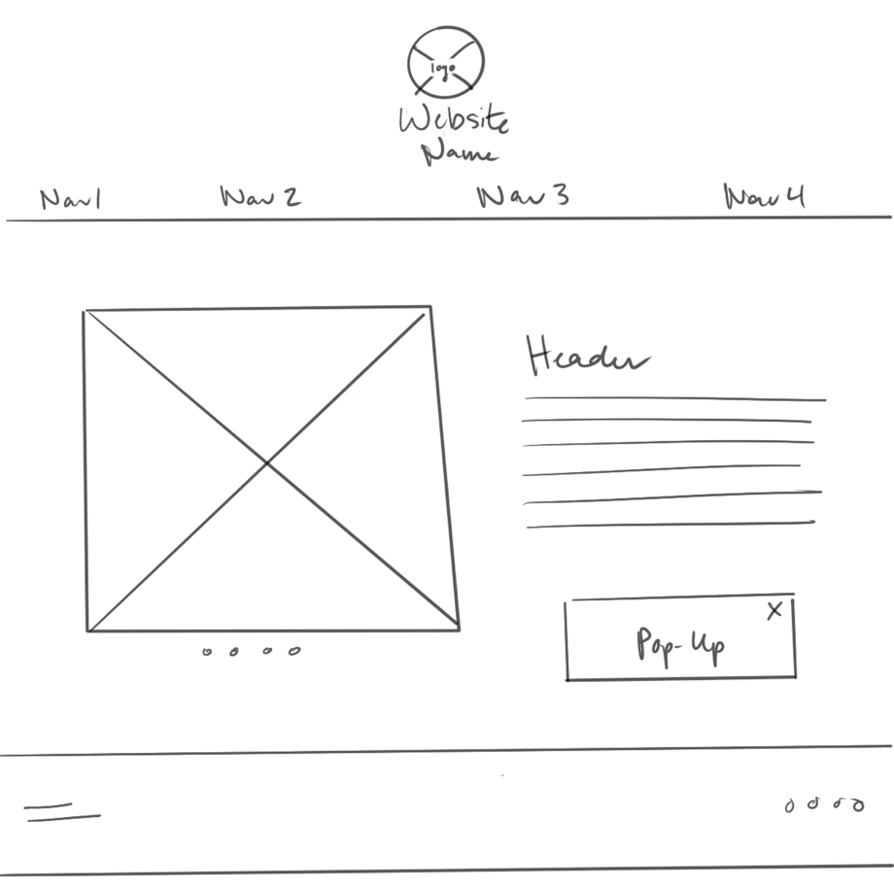

Figure 1: Main Page, Desktop

Figure 3 Grid View, Desktop

Figure 4 Grid View, Mobile

Figure 6 Detailed View, Mobile

Figure 5 Detailed View, Desktop

Figure 7 Favorites Grid, Desktop

Figure 8 Favorites Grid, Mobile

Figure 10 Newsletter, Mobile

Figure 9 Newsletter, Desktop